**Experiment**

**Aim:**

Write a shell script to display a demo using case…esac statement.

**Procedure:**

#!/bin/bash

flowers="Rose"

case "$flowers" in

"sunflower") echo " I love Sunflower";;

"Lotus") echo " I love Lotus";;

"Rose") echo " I love Rose";;

"Jasmine") echo " I love Jasmine";;

esac

**Output:**

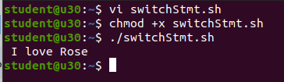

**Experiment**

**Aim:**

Write a shell script to display the capital of a state using case…esac statement.

**Procedure:**

#!/bin/bash

read -p "Enter a state name: " state

case $state in

"Kerala") echo "Thiruvanthapuram";;

"Karnataka") echo "Bengalure";;

"TamilNadu") echo "Chennai";;

"AndhraPradesh") echo "Amaravati";;

"Goa") echo "panaji";;

esac

**Output:**

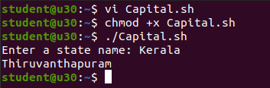

**Experiment**

**Aim:**

Write a shell script to display the colors in the rainbow using case…esac statement.

**Procedure:**

#!/bin/bash

read -p "Enter the letter of Rainbow to be searched : " Colors

case $Colors in

"v") echo "The Color searched is Violet";;

"i") echo "The Color searched is Indigo";;

"b") echo "The Color searched is Blue";;

"g") echo "The Color searched is Green";;

"y") echo "The Color searched is Yellow";;

"o") echo "The Color searched is Orange";;

"r") echo "The Color searched is Red";;

*) echo "The Color is not in Rainbow";;

esac

**Output:**

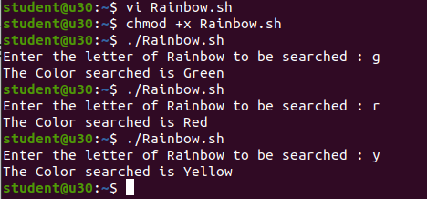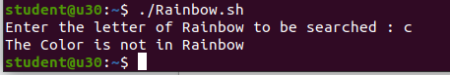

**Experiment**

**Aim:**

Write a shell script to display numbers in a certain limit using a while loop

**Procedure:**

#!/bin/bash

a=0

while [ $a -lt 10 ]

do

echo $a

a=`expr $a + 1`

done

**Output:**

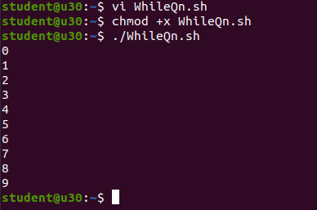

**Experiment**

**Aim:**

Write a shell script to print numbers in reverse order using a while loop.

**Procedure:**

#!/bin/bash

a=20

while [ $a -gt 0 ]

do

echo $a

((a--))

done

**Output:**

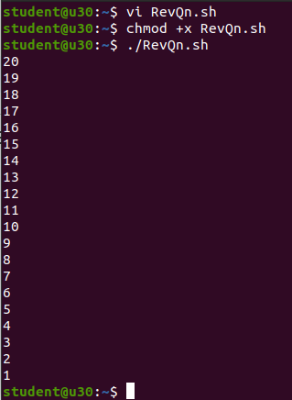

**Experiment**

**Aim:**

Write a shell script to check if a number is palindrome or not using a while loop.

**Procedure:**

#!/bin/bash

read -p "Enter the number to be checked : " num

org_num=$num

rev_num=0

reminder=0

while [ $num -gt 0 ]

do

remainder=$(( $num % 10 ))

rev_num=$(( $rev_num * 10 + $remainder ))

num=$(( $num / 10 ))

done

if [ $org_num -eq $rev_num ]

then

echo "The number is a palindrome."

else

echo "The number is not a palindrome."

fi

**Output:**

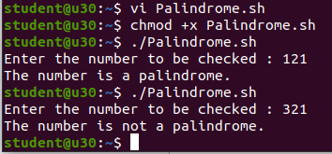

**Experiment**

**Aim:**

Write a shell script to demonstrate for loop (Sample program)

**Procedure:**

#!/bin/bash

for i in {1..7}

do

echo "welcome $i times"

done

**Output:**

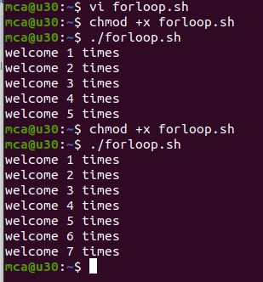

**Experiment**

**Aim:**

Write a shell script to implement for loop with break statement.

**Procedure:**

#!/bin/bash

read -p "Enter the limit : " n

for ((i=1; i<=n; i++))

do

echo "Current number: $i"

if ((i % 3 == 0))

then

echo "$i Divisible by 3!"

break

fi

done

**Output:**

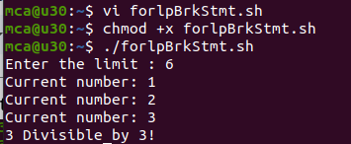

**Experiment**

**Aim:**

Write a shell script to implement for loop with continue statement.

**Procedure:**

#!/bin/bash

read -p "Enter the limit : " n

for ((i=1; i<=n; i++))

do

echo "Current number: $i"

if ((i % 3 == 0))

then

echo "$i Divisible by 3!"

continue

fi

done

**Output:**

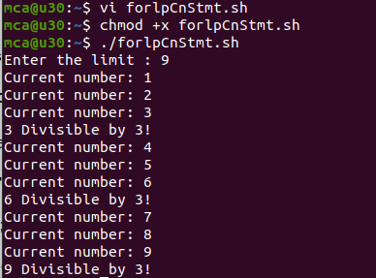

**Experiment**

**Aim:**

Write a shell script to display colors using for loop.

**Procedure:**

#!/bin/bash

for color in "green" "Yellow" "Red"

do

echo "Color: $color"

done

**Output:**

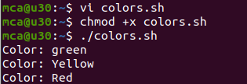

**Experiment**

**Aim:**

Write a shell script to display numbers upto 10 using for loop

**Procedure:**

#!/bin/bash

read -p "Enter a number: " num

for ((i=1; i<=$num; i++))

do

echo $i

done

**Output:**

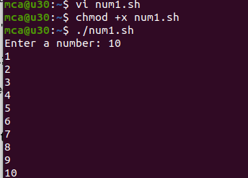

**Experiment**

**Aim:**

Write a shell script to count the numbers in reverse order.

**Procedure:**

#!/bin/bash

read -p "Enter a number: " num

for ((i=num; i>=1; i--))

do

echo $i

done

**Output:**

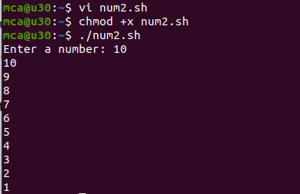

**Experiment**

**Aim:**

Write a shell script to display numbers from 2 to 15 using until loop.

**Procedure:**

#!/bin/bash

i=2

until [ $i -gt 15 ];

do

echo "number $i"

i=$(( i + 1 ))

done

**Output:**

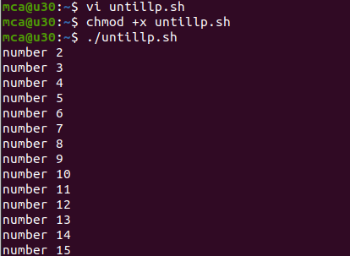

**Experiment**

**Aim:**

Write a shell script to call a function (Sample Program).

**Procedure:**

#!/bin/bash

hello(){

echo "Hello world"

}

hello

**Output:**

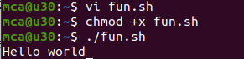

**Experiment**

**Aim:**

Write a shell script to implement a function (Sample Program).

**Procedure:**

#!/bin/bash

hello(){

echo "Hello world $1 $2"

}

hello sarath,432

**Output:**

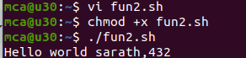

**Experiment**

**Aim:**

Write a shell script to check whether the number is palindrome or not using for loop.

**Procedure:**

**Output:**

**Experiment**

**Aim:**

Write a shell script to check whether a given number is Armstrong or not.

**Procedure:**

**Output:**

**Experiment**

**Aim:**

Write a shell script to check whether a number is prime or not.

**Procedure:**

**Output:**

**Experiment**

**Aim:**

Write a shell script for factorial of a number.

**Procedure:**

**Output:**

**Experiment**

**Aim:**

Write a shell script to print Fibonacci series

**Procedure:**

**Output:**

**Experiment**

**Aim:**

Write a shell script to check if the current year is a leap year or not.

**Procedure:**

**Output:**

**Experiment**

**Aim:**

Write a shell script to implement for loop with break statement.

**Procedure:**

**Output:**